Introducation to .Net
1. Introduction to .NET Framework 4.6
.NET Framework 4.6 is a software development platform by Microsoft that provides a runtime environment and libraries for building applications on Windows. It includes improvements in JIT compilation, garbage collection, security, and support for newer C# and VB.NET features.
2. What is .NET Platform?
The .NET Platform is a software development framework created by Microsoft that provides tools, libraries, and a runtime for building various types of applications, including web, desktop, mobile, gaming, and cloud applications. It supports multiple programming languages like C#, VB.NET, and F#.
3. What is .NET Framework?
.NET Framework is a software framework developed by Microsoft that provides a runtime environment and libraries for building Windows applications. It includes the Common Language Runtime (CLR) for executing code and a vast class library for different functionalities.
4. .NET Framework, Languages, and Tools
The .NET Framework supports multiple languages, including C#, VB.NET, and F#. It comes with development tools like Visual Studio, MSBuild, and NuGet for package management. These tools help developers build, debug, and deploy .NET applications efficiently.
5. .NET Framework Major Components
The major components of the .NET Framework include:
- Common Language Runtime (CLR): Executes .NET applications and manages memory, security, and exception handling.
- .NET Class Library: A set of pre-built reusable classes and functions.
- ASP.NET: A framework for building web applications.
- ADO.NET: Used for database connectivity.

6. Common Language Runtime (CLR)
The CLR is the core runtime environment of .NET, responsible for managing code execution, memory allocation, garbage collection, security enforcement, and exception handling. It allows code written in different .NET-supported languages to be executed seamlessly.
Garbage Collection: Garbage Collection in C# is an automatic memory management process performed by the .NET runtime that reclaims memory occupied by objects that are no longer accessible or needed by the application, helping to prevent memory leaks and improve performance.
7. The CLS (Common Language Specification)
The CLS is a set of rules and guidelines that .NET programming languages must follow to ensure interoperability. It defines how languages can interact with each other, ensuring that code written in one language can be used in another.
8. The CTS (Common Type System)
The CTS defines the data types and rules for declaring variables in .NET. It ensures that types used across different .NET languages have a common structure, enabling cross-language compatibility.
9. Value Types and Reference Types
- Value Types: Directly store data and are stored on the stack (e.g., int, float, bool).
- Reference Types: Store references (addresses) to data and are stored on the heap (e.g., class, string, object).
10. Compilation and Execution in .NET
.NET applications are compiled in two stages:
- Compilation to Intermediate Language (IL): The source code is first compiled into Microsoft Intermediate Language (MSIL).
- JIT Compilation: At runtime, the CLR’s Just-In-Time (JIT) compiler converts the IL code into machine code for execution.
11. Understand the .NET Framework 4.6 Stack
The .NET Framework 4.6 stack consists of:
- Base Class Library (BCL): Provides fundamental functions.
- CLR: Manages execution of .NET applications.
- Windows Presentation Foundation (WPF), Windows Forms, ASP.NET, ADO.NET: Various technologies for UI and database interaction.
- Entity Framework, LINQ, and other tools: Help in data access and manipulation.

· Introduction to .NET Core
.NET Core is an open-source, cross-platform framework developed by Microsoft for building modern applications. It supports Windows, macOS, and Linux and is optimized for cloud, microservices, and high-performance applications.
2. Characteristics of .NET Core
- Cross-platform: Runs on Windows, Linux, and macOS.
- Modular and lightweight: Uses NuGet packages to include only necessary components.
- High performance: Optimized runtime for speed and scalability.
- Open-source: Developed and maintained by Microsoft and the .NET community.
- Supports microservices and containers: Ideal for cloud-native applications.
3. The .NET Core Platform
The .NET Core platform consists of:
- CLR (Common Language Runtime): Manages execution of .NET applications.
- BCL (Base Class Library): Provides reusable classes and methods.
- ASP.NET Core: Framework for web applications and APIs.
- Entity Framework Core: ORM for database access.
4. .NET Core Architecture and Advantages
- Layered architecture: Separates concerns for better maintainability.
- Dependency Injection: Built-in support for modular applications.
- High scalability and performance: Uses Kestrel web server and efficient memory management.
- Side-by-side versioning: Allows multiple versions of .NET Core to run on the same machine.
5. Build and Run Cross-Platform Apps
.NET Core applications can be developed using Visual Studio, VS Code, or CLI tools. They can run on Windows, macOS, and Linux using Docker or native execution.

6. .NET Core – Environment Setup
To set up .NET Core:
- Install the .NET SDK from Microsoft’s official site.
- Use dotnet CLI (dotnet new console -o MyApp) to create a project.
- Use IDEs like Visual Studio or VS Code for development.
7. .NET Core – Code Execution
.NET Core applications execute in two steps:
- Compilation to IL (Intermediate Language): Source code is converted to IL.
- JIT (Just-In-Time) Compilation: IL is converted to machine code at runtime.
8. IoC Container & Middleware
- IoC (Inversion of Control) Container: Manages dependencies and services.
- Middleware: Components that process HTTP requests in ASP.NET Core (e.g., authentication, logging, routing).
9. .NET Core – Modularity
.NET Core is modular because it allows developers to include only necessary libraries using NuGet packages, making applications lightweight and optimized.
10. .NET Core – Project Files
.NET Core project files include:
- .csproj (Project File): Defines project settings and dependencies.
- Program.cs: Entry point of the application.
- appsettings.json: Configuration file for app settings.
11. IIS Self-Hosting & Different Cross-Platform Deployments
.NET Core applications can be deployed in multiple ways:
- IIS Hosting: Deploy ASP.NET Core apps on Windows servers.
- Self-Hosting: Use Kestrel, a built-in web server for .NET Core.
- Docker: Containerize .NET Core applications for cross-platform deployment.
12. Microservices using .NET Core
.NET Core is ideal for microservices architecture because it:
- Supports lightweight, independent services.
- Works well with Docker and Kubernetes.
- Has built-in support for REST APIs with ASP.NET Core.
13. .NET Core – Windows Runtime and Extension SDKs
.NET Core integrates with Windows APIs using Windows Runtime (WinRT) and allows developers to extend functionality using Extension SDKs for specific features like Bluetooth, Sensors, or UI controls.
14. .NET Core – Create .NET Standard Library
.NET Standard is a specification that ensures code compatibility across different .NET implementations. Developers can create a .NET Standard Library to share code across .NET Framework, .NET Core, and Xamarin.

15. Comparison between .NET Framework & .NET Core
Feature | .NET Framework | .NET Core
Cross-Platform | No | Yes
Open-Source | Partially | Fully
Performance | Slower | Faster
Microservices Support | Limited | Full Support
Deployment | Windows-only | Cloud & Linux support
16. Introduction to Dependency Injection
Dependency Injection (DI) is a design pattern used in .NET Core to:
- Improve modularity and testability.
- Reduce tightly coupled dependencies.
- Allow dynamic service registration using built-in DI containers.

· Debugging in C#
1. Various Types of .NET Projects
.NET supports different types of projects depending on the application's needs. Below are the most common project types:
- Console Applications
  - Command-line applications running in a terminal.
  - Ideal for scripts, automation, or backend processes.
  - Uses Console.WriteLine() for output.
- Windows Forms Applications
  - Desktop applications with graphical user interfaces (GUI).
  - Uses System.Windows.Forms for UI elements.
  - Suitable for business applications.
- ASP.NET Web Applications
  - Used to create dynamic websites and web APIs.
  - Supports MVC (Model-View-Controller), Razor Pages, and Blazor.
  - Runs on IIS or Kestrel web server.
- WPF (Windows Presentation Foundation) Applications
  - Modern UI-based desktop applications.
  - Uses XAML for designing UI components.
  - Provides rich graphics, animations, and data binding.
- Class Libraries
  - Reusable code libraries (.dll files).
  - Used in multiple projects to share logic.
- Web API
  - Backend services that provide JSON/XML responses.
  - Uses ASP.NET Core Web API to create RESTful services.
- Blazor Applications
  - Web applications using C# and .NET instead of JavaScript.
  - Can run on the server (Blazor Server) or the client (Blazor Web Assembly).
- Xamarin/Maui for Mobile Development
  - Create cross-platform mobile apps using .NET.
  - Supports Android and iOS development.

2. Tracing, Debugging, Build
These are three different stages in software development:
- Tracing
  - Used to log and analyze application flow and events.
  - System.Diagnostics.Trace.WriteLine("Log Message");
  - Helps in production environments.
- Debugging
  - Process of finding and fixing errors (bugs).
  - Uses breakpoints, step-by-step execution, and variable inspections.
  - Done using Visual Studio Debugger.
- Build
  - Compiling source code into an executable (.exe or .dll).
  - Debug vs. Release build:
    - Debug Mode: Includes additional debugging information.
    - Release Mode: Optimized for performance, without debug data.

3. Compile Options
Compilation settings affect how code is built and executed:
- Debug vs. Release Mode
  - Debug Mode: Includes debug symbols for easier debugging.
  - Release Mode: Optimized for performance, removes debugging data.
- Optimization Settings
  - optimize compiler flag enables optimizations.
  - Can remove unused variables and inline functions.
- Conditional Compilation
  - Allows executing different code based on the build configuration:
- Platform Target Settings
  - Choose between x86, x64, or Any CPU to target specific hardware.

4. Using Breakpoints
Breakpoints allow pausing execution at specific points in the code:
- Setting a Breakpoint
  - Click in the left margin in Visual Studio or press F9 on a line of code.
- Using Breakpoints to Debug
  - Run the program in Debug Mode (F5).
  - When execution reaches a breakpoint, it pauses.
  - Inspect variables and step through the code.

5. Using Break Conditions
Sometimes, you want a breakpoint to hit only when a condition is met:
- Conditional Breakpoint Example
  - Right-click a breakpoint > Condition…
- Hit Count Breakpoint
  - Pause execution only after a breakpoint is hit a certain number of times.

6. Debugging Exceptions
When an exception occurs, the debugger can catch and show detailed information:
- Enable Exception Handling
  - Press Ctrl + Alt + E in Visual Studio.
  - Check Common Language Runtime Exceptions.
- Inspect Exception Details
  - Use the Exception Helper window to see details about errors.
- Use Try-Catch Blocks
try
{
int result = 10 / 0; // This will cause a divide-by-zero exception
}
catch (DivideByZeroException ex)
{
Console.WriteLine("Exception caught: " + ex.Message);
}
7. Using Watch and Output Window
Watch Window
- Used to monitor variable values dynamically.
- Open in Visual Studio: Debug > Windows > Watch > Watch 1.
- Add variables to track changes during debugging.
Output Window
- Displays logs, debugging messages, and build status.
- Useful for monitoring application behavior.

8. What are Diagnostics?
Diagnostics tools help analyze the application's behavior:
- Event Viewer
  - Logs application events and crashes.
- Performance Counters
  - Monitor CPU usage, memory, and network activity.
- Debug Logs
Debug.WriteLine("Debugging message");
Trace.WriteLine("Tracing message");

9. Debug and Trace Classes
Used for logging application events:
- Debug Class (Only runs in debug mode)
Debug.WriteLine("Only appears in debug mode");
- Trace Class (Works in both Debug and Release mode)
Trace.WriteLine("Appears in both debug and release mode");

10. Creating Multiple Projects within One Solution
A solution can contain multiple projects:
- Why Use Multiple Projects?
  - Separation of concerns (UI, business logic, and database).
  - Easier to maintain and test.
- How to Add a New Project in Visual Studio
  - Right-click Solution Explorer > Add New Project.
11. Customizing Visual Studio Settings
Visual Studio can be customized for better efficiency:
- Modify Themes and Layouts
  - Tools > Options > Environment > General.
  - Choose Light, Dark, or Blue themes.
- Change Keyboard Shortcuts
  - Tools > Options > Keyboard.
- Manage Extensions
  - Install plugins via Extensions > Manage Extensions.
- Configure NuGet Package Manager
  - Manage dependencies using Tools > NuGet Package Manager.

OOP’S with C#
1. Structures and Enums
Structures (struct)
- A value type used to group related variables.
- Unlike classes, structs do not support inheritance.
- Used for lightweight objects.
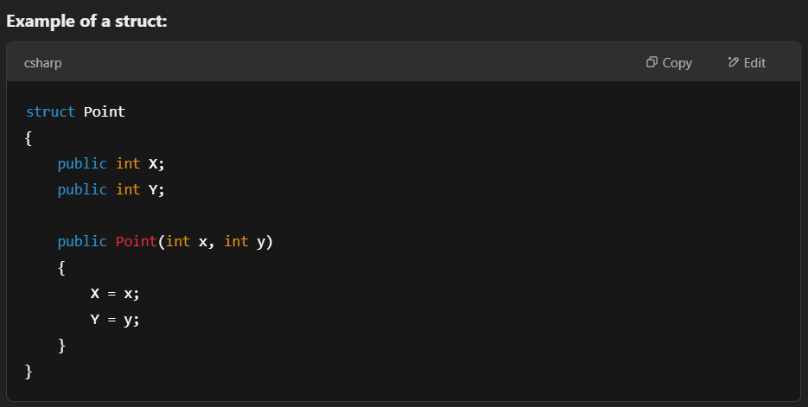

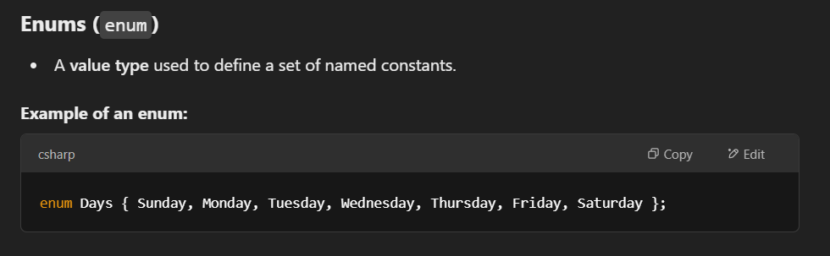

Evaluating Regular Expressions in C#
1. RegEx Class
- The System.Text.RegularExpressions.Regex class is used to work with regular expressions in C#.
- It allows pattern matching in strings—e.g., validating an email address, finding specific text patterns, etc.
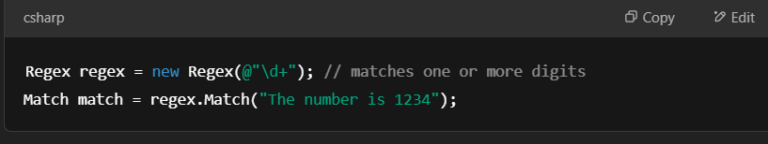
2. Forming Regular Expressions
- Regex patterns consist of symbols and characters that represent sets, positions, or repetitions.
- Examples:
  - \d → any digit
  - \w → any word character
  - ^ → start of string
  - $ → end of string
  - *, +, ? → repetition operators
3. Methods for Regular Expression
- Match() – finds a match in a string
- Matches() – finds all matches
- IsMatch() – checks if a match exists
- Replace() – replaces matched substrings
- Split() – splits a string based on a pattern
🛠️ Exception Handling in C#
1. Exceptions in C#
- Exceptions are runtime errors that disrupt normal program flow.
- Common examples: NullReferenceException, DivideByZeroException, FileNotFoundException
2. Exception Class Hierarchy
- All exceptions derive from System.Exception.
- Base hierarchy:
  - System.Exception
    - System.SystemException
    - System.ApplicationException
3. Try Block
- Code that might throw an exception is placed in a try block.
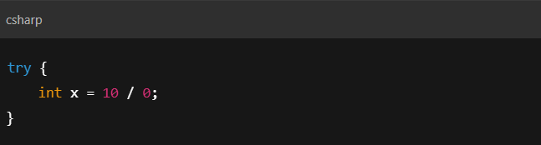
4. Multiple Catch Blocks
- Catch different types of exceptions separately.
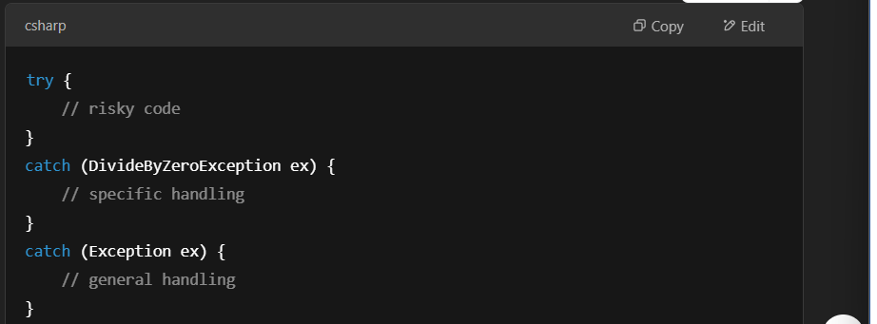
5. Finally Block
- Executes whether or not an exception occurs.
- Used for cleanup like closing files or releasing resources.
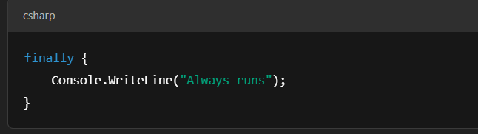
6. Purpose of throw Keyword
- Used to throw an exception manually or rethrow caught exceptions.
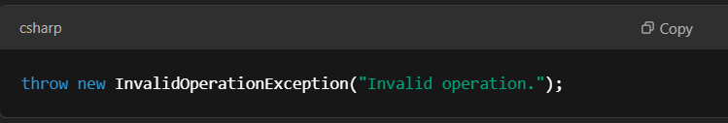
7. Purpose of Inner Exception
- Helps to retain the original exception when rethrowing a new one.
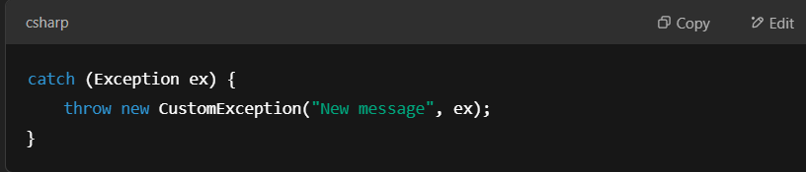
8. Creating Custom Exception
- You can define your own exception by extending Exception.
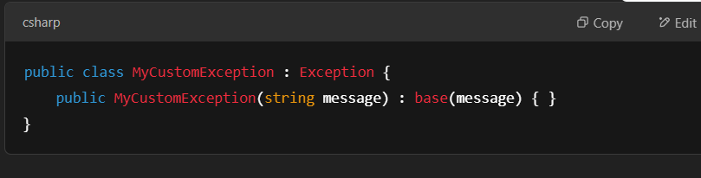

♻️ Garbage Collection in C#
1. Role of a Garbage Collector
- Automatically reclaims memory used by unreferenced objects.
- Eliminates the need for manual memory management like in C++.
2. Garbage Collection Algorithm
- C# uses a generational garbage collector:
  - Gen 0: short-lived objects
  - Gen 1: medium-lived objects
  - Gen 2: long-lived objects
- When GC runs:
  - Pauses app (Stop-the-world)
  - Frees unused memory
  - Compacts the heap
3. Finalize vs Dispose
- Finalize: used for cleanup by the GC, but non-deterministic.
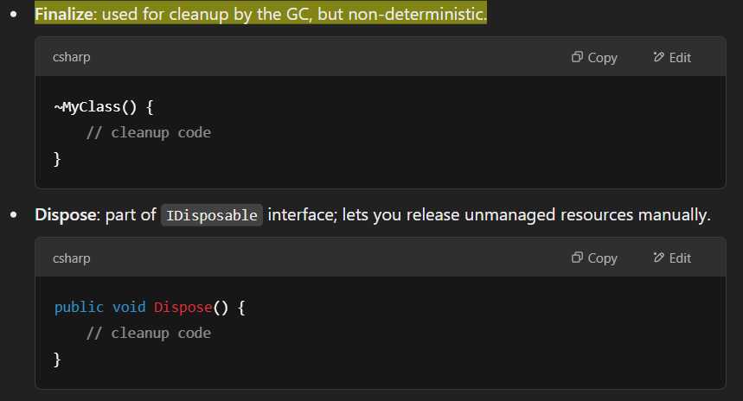

📦 Collections & Generics in C#
1. System.Collections Namespace
- Contains non-generic collection classes like:
  - ArrayList
  - Hashtable
  - Queue
  - Stack
- These collections store data as object, requiring type casting, which may reduce performance and type safety.
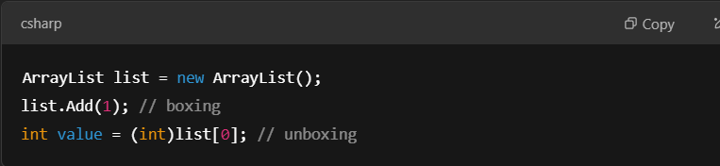
2. Collection Interfaces
- Define standard operations for collections:
  - IEnumerable – allows iteration using foreach
  - ICollection – base interface for all collections (Count, CopyTo)
  - IList – supports indexing
  - IDictionary – key-value pairs

3. Collection Classes
- Ready-to-use implementations:
  - Non-generic (from System.Collections): ArrayList, Stack, Queue, Hashtable
  - Generic (from System.Collections.Generic): List<T>, Dictionary<TKey, TValue>, Queue<T>, Stack<T>, HashSet<T>
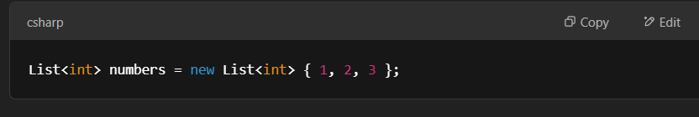
4. The Collection API
- The .NET Collection API includes various classes and interfaces that provide storage and manipulation capabilities for objects.
- Includes methods like Add(), Remove(), Contains(), Sort(), etc.

5. Working with Generics
- Generics allow defining classes, methods, and interfaces with a placeholder for the type.
- Improves type safety and performance by eliminating boxing/unboxing.
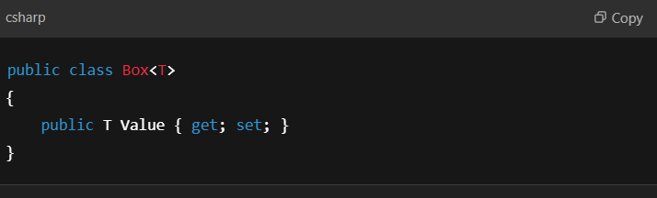
6. Creating Generic Class, Generic Methods, Interfaces, Delegates
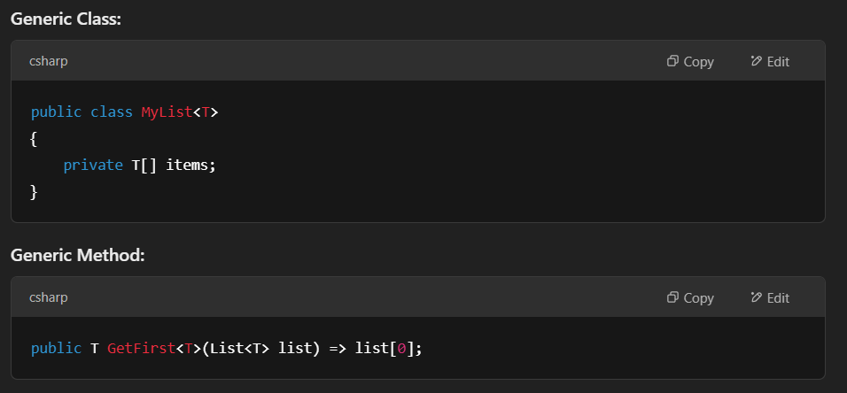

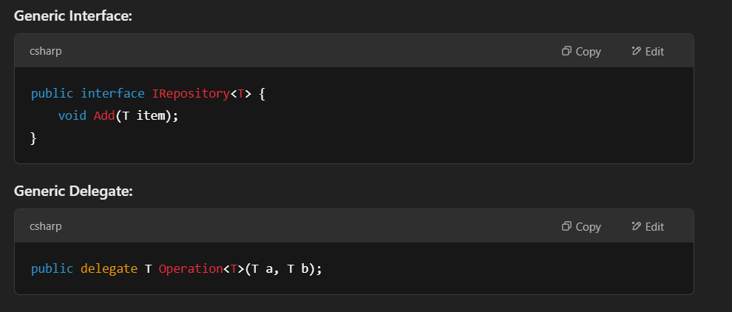
7. Collection Initializers
- Simplified way to initialize collections.
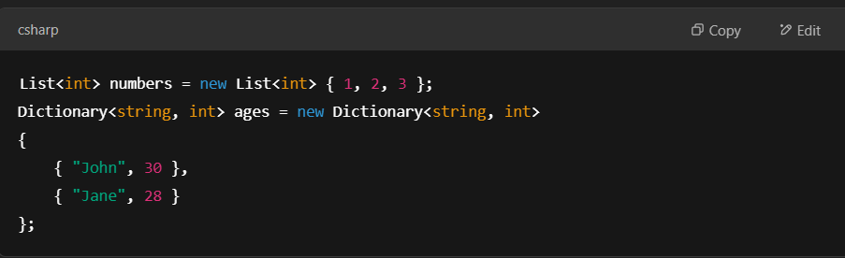
8. Iterators
- Used to create custom iteration logic using yield return.
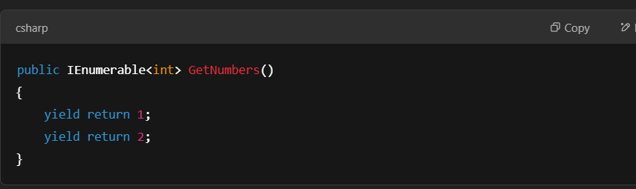
9. IEnumerable, IEnumerator, IComparer Interfaces
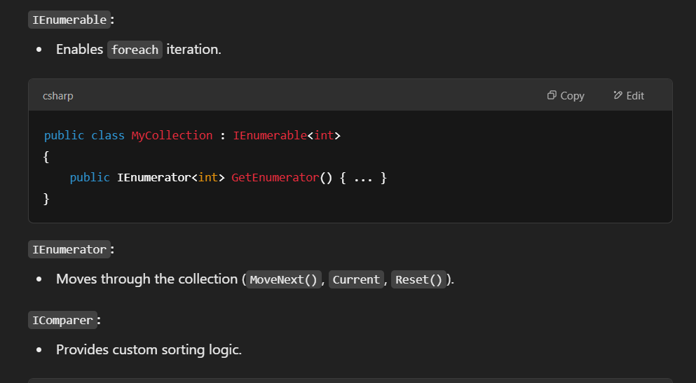
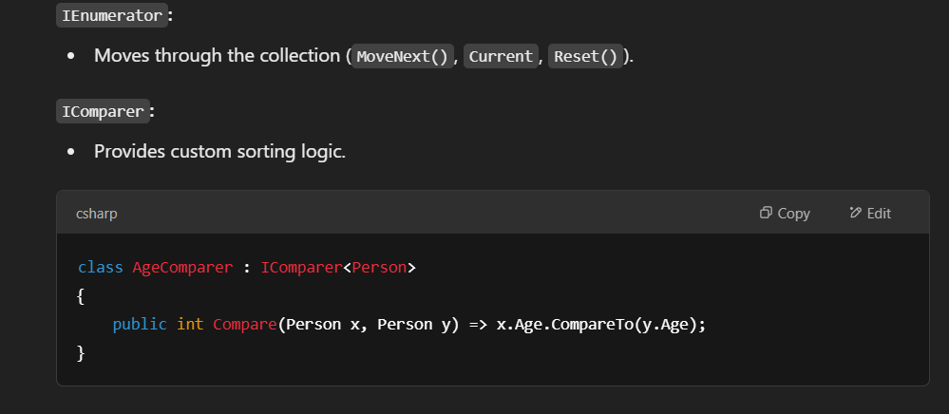

10. Constraints
- Restrict types that can be used as arguments for generics.
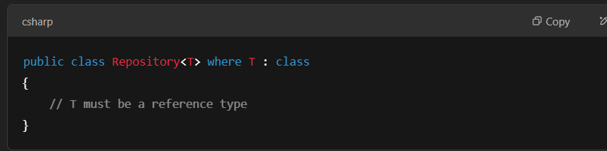
Other constraints:
- where T : new() – must have a public parameterless constructor.
- where T : SomeBaseClass – must inherit from SomeBaseClass.
- where T : ISomeInterface – must implement ISomeInterface.

1. Automated Testing with MSTest and Async
🔹 What is MSTest?
- MSTest is a test framework developed by Microsoft.
- It's used in .NET applications for writing and running unit tests.
- Works well with Visual Studio and integrates with build systems like Azure DevOps.
🔹 What is Async Testing?
- In modern applications, many operations are asynchronous (like file I/O, HTTP requests, database calls).
- Async unit testing lets you test asynchronous methods using async/await.
🧪 Key Concepts in Async MSTest:
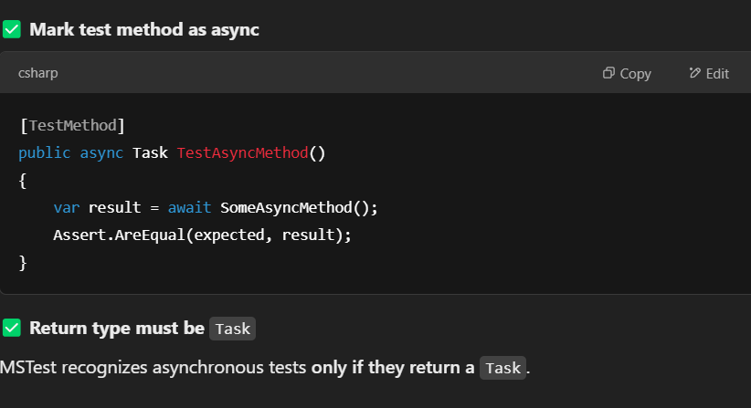
2. Programming in .NET and NUnit
🔹 .NET Overview
- A cross-platform framework developed by Microsoft for building modern apps (web, desktop, mobile, cloud).
- Supports C#, F#, VB.NET, etc.
- Used with Visual Studio for development.
🔹 What is NUnit?
- NUnit is an open-source unit testing framework for .NET.
- It's similar to MSTest but often more flexible and extensible.
- Highly popular in enterprise and open-source projects.
🧪 Basic NUnit Test Example
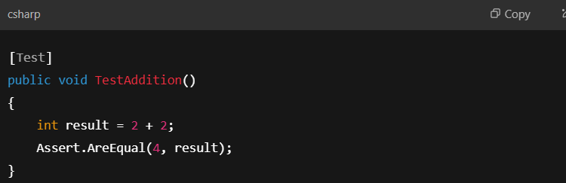
Benefits of NUnit in .NET:
- Better parameterized tests
- Strong assertion library
- Active community support
- Works great with CI/CD pipelines

Main Topic: Using Asserts to Pass or Fail Tests
Asserts are used in unit testing to verify that a condition is true. If an assertion fails, the test fails, indicating that something is wrong in the code.

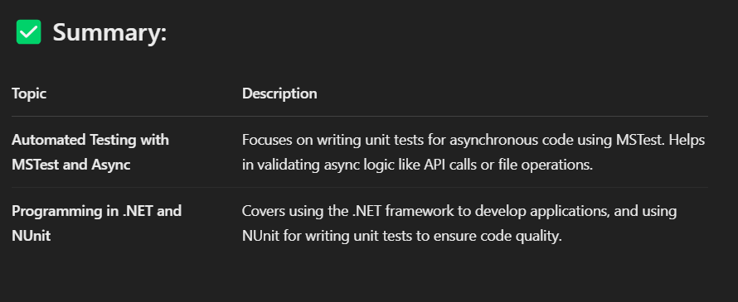
Sub-Topics Explained
1. Controlling and Customizing Test Execution
This refers to ways you can manage how and when tests run.
- Categories: Group tests for selective running.
- Attributes like [SetUp], [TearDown]: Run before/after each test.
- Time constraints: Use [Timeout] to fail slow tests.
- Order of execution: Control which tests run first (though this should be avoided when possible).
Example:
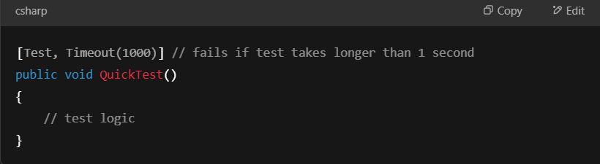
2. Creating Data Driven Tests
These are tests that run multiple times with different inputs (parameters).
- In NUnit, this is done with:
  - [TestCase]
  - TestCaseSource]
  - [Values], [Range], [Combinatorial] for parameterized tests
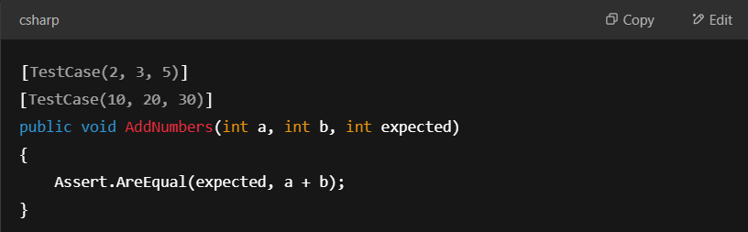

3. Reducing Code Duplication and Increasing Test Readability
This involves writing cleaner, reusable tests to avoid repetition.
Ways to achieve this:
- Use helper methods for repeated logic.
- Use parameterized tests to avoid writing the same test with different values.
- Use [SetUp] for shared setup code.
Example:
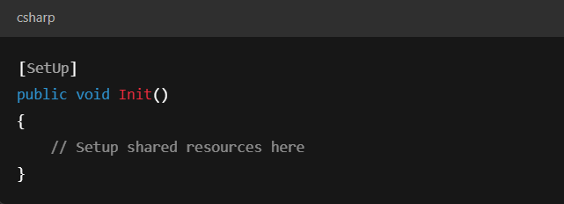
4. Writing Your First NUnit Test
Basic structure of writing and running a simple NUnit test.
Steps:
- Create a test class and decorate it with [TestFixture] (optional in newer NUnit versions).
- Write a method with [Test] attribute.
- Use Assert to test logic.
Example:
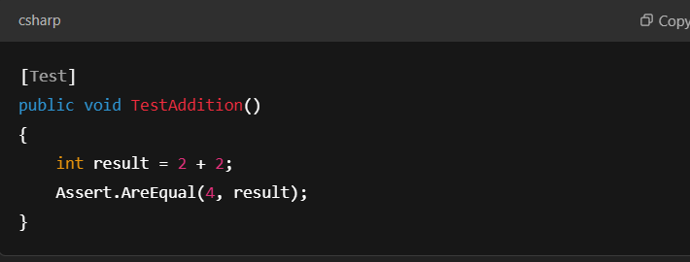
5. Understanding NUnit Tests
NUnit is a popular unit-testing framework for C#.
Key concepts:
- Test Attributes: [Test], [SetUp], [TearDown], etc.
- Assert Methods: Assert.AreEqual(), Assert.IsTrue(), Assert.Throws(), etc.
- Test Results: A test can pass, fail, or be ignored.

6. Asserting on Different Types of Results
Asserts can check for:
- Equality: Assert.AreEqual()
- Boolean values: Assert.IsTrue(), Assert.IsFalse()
- Exceptions: Assert.Throws(), Assert.DoesNotThrow()
- Null values: Assert.IsNull(), Assert.IsNotNull()
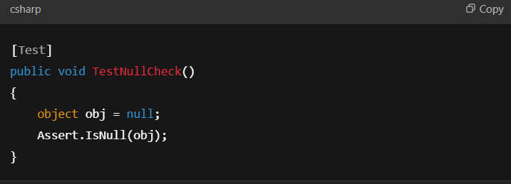

7. Controlling Test Execution
Focuses on managing test flow and behavior:
- Skip tests: [Ignore("reason")]
- Run only specific ones: By using test Category or Filter
- Explicit execution: [Explicit] marks tests that only run when explicitly requested
Example: 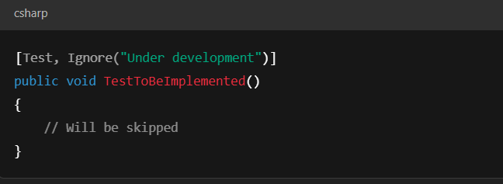

8. Creating Data Driven Tests and Reducing Test Code Duplication
A combination of points 2 and 3:
- Use parameterized tests to handle multiple test cases in one method.
- Prevent boilerplate and redundancy by using common test logic.
Example: 